Examining Differences in Opioid Prescriptions by Severity-Level of Opioid Overdose Deaths

Naomi Giertych

For the past decade, opioids and other drug-related problems have come heeded particular attention in the media. Politicians have responded by creating oversight agencies and additional regulations for opioid prescriptions. Government and private agencies have also started monitoring opioid and other drug-related deaths. For instance, the Henry J. Kaiser Family Foundation publishes state-level opioid overdose deaths rates per 100,000, and the CDC publishes state-level opioid and drug-related overdose deaths rates per 100,000 and “groups” the states based on the severity-level. A natural question, therefore, is how are the driving factors of opioid prescriptions for states in one severity-level different than states in another severity-level.

To answer this question, I use the 2015 Medicare Part D Prescriber data, the 2015 Medicare Physician and Other Prescriber data, and the Kaiser and CDC state-level opioid overdose deaths rate data mentioned above. The 2015 Medicare Part D Prescriber data contains information about the total days supplied of each drug prescribed by a doctor and information about where the prescriber operates; it contains a total of 24.5 million observations. The 2015 Medicare Physician and Other Prescriber data contains detailed information about a doctor such as where they operate, their primary specialty (a.k.a. Provider type), and the total number of times they perform a specific procedure; it contains a total of 9.5 million observations. I use the full 2015 Medicare Part D Prescriber data and a subset of the 2015 Medicare Physician and Other Prescriber data which contains only the physicians in the both files.

Finally, I use the CDC’s severity-level grouping to classify each state into a severity-level based on the corresponding rate in the Kaiser data. For instance, the CDC classifies states with a drug-overdose death rate of less than or equal to 11% (per 100,000) as being “very low”. Nebraska has an opioid death rate of 6.9% (per 100,000) from the Kaiser data and would be classified as “very low”. Below is a table for the number of states and observations contained in each of these severity-levels. The number of observations is not very balanced between the severity-levels.

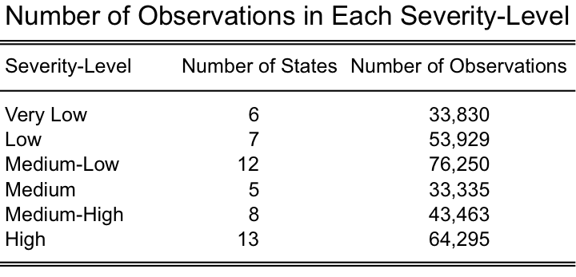

I then explore how provider types and procedure types differ between severity-level groups by fitting a two models for each severity-level group. First, I log-transform the total days supplied of opioids and the total days supplied of non-opioids and for each group. Second, I perform a truncated SVD to the 2015 Medicare Physician and Other Prescriber data to obtain the first 50 principal components (PC’s) for the procedures. I then regress the log number of opioids to the log number of non-opioids and either the physician type or the 50 procedure PC’s and use LARS to perform variable selection on these models.

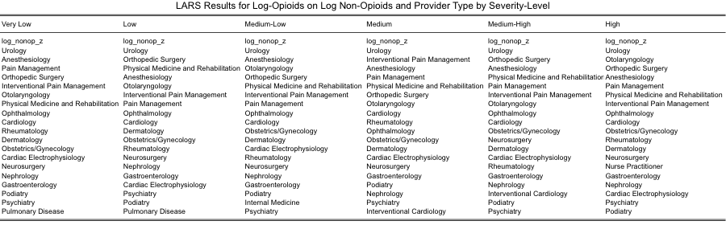

*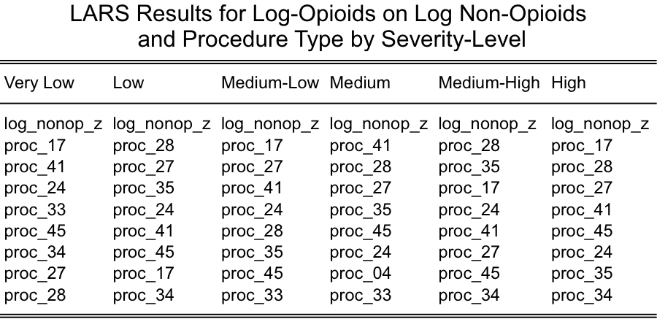*

Finally, the models differ quite a bit between the severity-level groups as seen in the tables above. Focusing on the models with the provider types, log non-opioids and urology are the top two predictors for the log opioids prescribed for each severity-level group. The next best predictors for log opioids consist of some permutation of the same predictors in each group. This suggests that overall the log number of opioids is driven by these provider types and the severity-level grouping may not driven by a specific mix of provider types. In other words, no severity-level group is dominated by a few provider types. Focusing on the models with the procedure PCs, the log non-opioid is the first predictor chosen for all the the severity-level groups. This is not surprising since this is accounting for the number of patients a provider sees. Interestingly, only eight of the PCs are chosen by LARS to explain the remaining variation in log opioids prescribed. Additionally, the procedure PCs chosen for each severity-level differ quite a bit. For instance, PC 33 is chosen for the very low severity-level but is not chosen for the low severity-level. This suggests that some procedures may be driving the number of opioids prescribed in one severity-level group more than for another group.

Sources:

2015 Medicare Part D Prescriber Data. <https://www.cms.gov/Research-Statistics-Data-and-Systems/Statistics-Trends-and-Reports/Medicare-Provider-Charge-Data/PartD2015.html>

2015 Medicare Physician and Other Prescriber data. <https://www.cms.gov/Research-Statistics-Data-and-Systems/Statistics-Trends-and-Reports/Medicare-Provider-Charge-Data/Physician-and-Other-Supplier2015.html>

Henry J. Kaiser Family Foundation. <https://www.kff.org/other/state-indicator/opioid-overdose-death-rates/?currentTimeframe=1&sortModel=%7B%22colId%22:%22Location%22,%22sort%22:%22asc%22%7D>

CDC. <https://www.cdc.gov/drugoverdose/data/statedeaths.html>